**Web Filtering Checks Template**

The [DfE Filtering and Monitoring Standards](https://www.gov.uk/guidance/meeting-digital-and-technology-standards-in-schools-and-colleges/filtering-and-monitoring-standards-for-schools-and-colleges) (which schools are asked to follow in [Keeping Children Safe in Education](https://www.gov.uk/government/publications/keeping-children-safe-in-education--2)) require schools to perform ***regular checks*** on filtering systems so that “governing bodies and proprietors have assurance that systems are working effectively and meeting safeguarding obligations”.

**Check versus review – are they the same?**

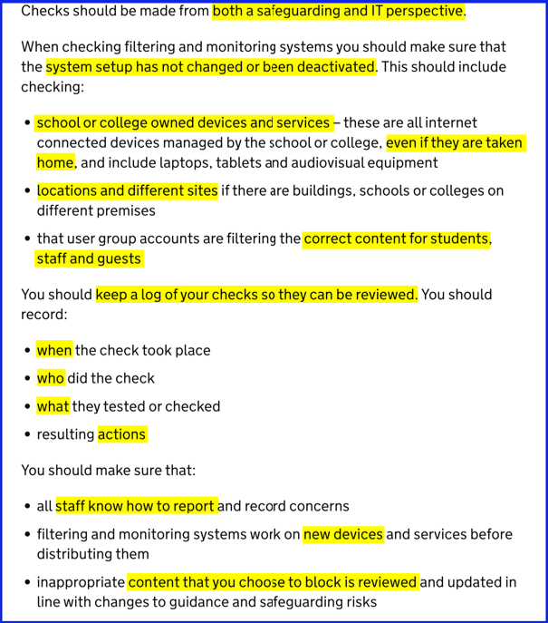

*Screenshot from the standards with key elements highlighted (as of summer 2025)*

These are not the same thing:

* checks are regular and operational: ensuring devices, platforms and accounts continue to be filtered as planned
* the review is annual (or after major changes) and strategic, best to do as part of your [online safety audit](https://onlinesafetyaudit.lgfl.net/)

See [safefiltering.lgfl.net](https://safefiltering.lgfl.net) for a video on the differences, or to download this form again.

**How often?**

There is no definition of ‘regular’, but we recommend half-termly as a useful interval.

**What are we checking?**

The next page has a pro forma to edit and use for checks with lots of ideas. The screenshot here shows you what the standards talks about.

You need to consider and document your exact plan for who, what, when and how to log and follow up on necessary actions. This should be based on your context and need.

**Who needs to do it?**

The DSL has overall responsibility and should be part of planning and receiving reports on results, actions and follow-ups, but they do not need to carry out the checks, as long as results and actions are reported back for discussion and review. Remember also the key role of ALL staff in feeding back.

**What are we trying to find out?**

In essence, you want to know:

* Are key things blocked?
* Are we ‘overblocking’?
* Has anything changed?
* Is filtering ACTIVE EVERYWHERE (all connections & devices & users)?
* Is Safe Search ENFORCED (i.e. can't be turned off) EVERYWHERE (as above)?
* Are there concerns about students bypassing blocks?

Before you start, make sure you have liaised with your tech team to identify all types of user, device, account and physical location (remember portacabins, trolleys, home devices, guest networks and BYOD and the most recent new or rebuilt device) and have scheduled your checks to cover all of these over the academic year.

Use the following proforma to log the checks that take place in your school. Feel free to edit this template and add your school logo but please do not remove the LGfL branding or copyright notice.

**NB** – please note that DSLs and others can have access to the SchoolProtect portal with stripped back access for reporting, overviews and simple block/unblock changes – just ask an existing admin to log in and go to > Settings > User Management and add you as the ‘Editor’ role.

**2025/2026 Schedule**

|  |  |  |  |
| --- | --- | --- | --- |
| **Time and date** | **Focus of the checks for this half term** | **Carried out by** | **Report back to (insert names of DSLs, tech contacts and other stakeholders)** |
| *1 -* |  |  |  |
| *2 -* |  |  |  |
| *3 -* |  |  |  |
| *4 -* |  |  |  |
| *5 -* |  |  |  |
| *6 -* |  |  |  |

**~ FORM BEGINS OVERLEAF ~**

|  |  |  |  |
| --- | --- | --- | --- |
| **Time and date:** |  | **Completed by:** |  |
| **Device type and location checked:**  (list the device IDs here also) |  | **Type of user account / system checked:**  (list the accounts here also) |  |

|  |  |  |  |
| --- | --- | --- | --- |
|  | Delete the sections in *italics* below which do not apply to you  (LGfL school, non-LGfL school, etc) | **Any issues?**  Checkmark with solid fill or Close with solid fill | **Details and any Actions**  *(Who, what, how, by when)* |
| 1 | **Have all actions from the last filtering checks been completed/closed?**  If there is anything outstanding, note it here so you do not forget. |  |  |
| 2 | **Is filtering active (turned ON) for the device/account/location you are checking?**  *Non-LGfL school* – ask your technician/provider how best to do this.  *LGfL school* – visit [amifiltering.co.uk](https://amifiltering.co.uk) – this simple test website will give you a green tick if you are filtering (whether via HomeProtect or SchoolProtect). |  |  |
| 3 | **Is the correct policy assigned?**  *Non-LGfL school* – ask your technician/provider how best to do this.  *LGfL schools which are using DECRYPTION\*\** – on the same (Am I Filtering?) site mentioned above, you will see policy details next to the green tick. This will tell you for example “Key Stage 2” or “Admin Staff”. If that is what you expect, then all is good. If you are checking a staff device/account but it names a pupil policy, your settings are not correct.  *LGfL schools which are not using DECRYPTION\*\** - you will need to visit <http://wsblock.co.uk> and scroll down to see ‘Additional Information’. Please note, however, that you must type http at the start, not https because you are not decrypting. This Additional Information link will tell you your policy group – for example “Key Stage 2” or “Admin Staff”. If that is what you expect, then all is good. If you are checking a staff device/account but it names a pupil policy, your settings are not correct.  *\*\*Decryption is essential to have granular and flexible filtering and to comply with DfE Standards. Find out more at* [*whydecrypt.lgfl.net*](https://whydecrypt.lgfl.net/) |  |  |
| 4 | **Are all important categories blocked (illegal, adult, inappropriate, unhelpful, etc)? Does this correspond with what you expect to see?**  *Non-LGfL school* – ask your technician/provider how best to do this. Beware, if you visit inappropriate sites for testing you should get approval first, log this action for your own protection and consider carefully which to use (e.g. guinness.com, paddypower.com); do not visit real adult sites for testing.  *LGfL school* – you do not need to visit websites but can again use our Am I Filtering? test tool. Once the site confirms you are being filtered by LGfL, scroll down to see lists of the categories blocked and allowed (no login required). Note this is for the exact device/account in use at the time, hence it is important to test different ones. The lists tell you which categories all schools should block, most schools block etc to give you a guide. Please note that to see what is happening across all categories, you should log into the system and access the categories page to see how they affect all groups. |  |  |
| 5 | **Is your YouTube mode as expected?**  Which of the two restricted modes can you see – visit [youtubemode.lgfl.net](https://youtubemode.lgfl.net) to test this.  Find out more about YouTube modes at [youtube.lgfl.net](https://youtube.lgfl.net) |  |  |
| 6 | **Is Safe Search on and ENFORCED for all search engines you use?**  It is vital that this cannot be turned off by users.  For Google, visit [safesearchcheck.lgfl.net](https://safesearchcheck.lgfl.net) and be sure you cannot toggle it off.  (You may wish to block the ‘search engine’ category for all users and override this only for the one or several which you permit and can guarantee an enforceable safe search for) |  |  |
| 7 | **Is a website or page which you specifically blocked / unblocked recently or after the last set of checks correct for all users/accounts/devices?**  Remember this may be different for different Key Stages or classroom v office staff for example. |  |  |
| 8 | **Audit log (coming soon for LGfL*)**  Non-LGfL Schools – Ask how you can see which settings have changed in the last half term and if these were approved/need reviewing.  LGfL Schools – we will soon* be launching an audit log of changes on the system. This will allow you to check who changed what and if it was approved. Meanwhile, simply ask your tech team what they have changed in the past half term.  *available from October half term. |  |  |
| 9 | **Best practice settings? Filtering Health Check\***  Non-LGfL Schools – Ask if you can have a review of your settings  LGfL Schools – when you log into SchoolProtect* you will see a filtering health check to display whether your settings follow best-practice or not. Visit this page to see which items you may wish to change for a more granular and safe experience.  * If you are using this prior to September 25, see [this newsletter](https://viewonline.lgfl.net/new-info-for-dsls-on-safe-web-filtering?hs_preview=ATVlvQvL-191165779837#hs_cos_wrapper_module_17518937663108_) for how to access the health check. From September, you simply see the health check on the home page when you log in. |  |  |
| 10 | **Have you asked staff & pupils if they have recently been unable to access educational sites or stumbled across inappropriate sites?**  It is wise to send an email reminder to staff when you do these checks that they should be notifying you as soon as they see/hear/experience something around circumventing the system or also overblocking and difficulties online.  Consider what system there is to report instantly (an online form may be better for their responses than lots of emails)? |  |  |