Dear Parents and Carers,

**Please edit the following text / delete as appropriate. Feel free to paste into your school letterhead / add your logo and share with parents in any way.**

**Staying safe and being a good friend on apps, sites and games**

Each year, children are spending more time on devices and so here is some information about principles for keeping safe online that we would encourage you to discuss with your child.

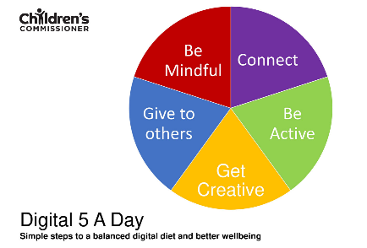

Instead of focusing solely on the amount of time your child spends on screens, think instead about what they are doing online, and whether this represents a quality ‘**digital diet’**. How does their online activity impact on their physical and mental wellbeing?

The Children's Commissioner’s ‘Digital Five a Day’ framework has five things to think about each day to help put that into practice.

Speak to your child and agree some basic boundaries, such as screen-free times of the day (e.g. during mealtimes, during lessons at school etc.) or locations (e.g. in bedrooms), when devices should be switched off for the day (e.g. what time in the evening?) and where devices should be kept at nighttime to avoid their addictive pull. You could use the digital family agreement at [parentsafe.lgfl.net](https://parentsafe.lgfl.net) to help you with this.

We know how important it is to children that they use technology (apps and games) to stay in touch with their friends. Although please note that the age restriction for all popular social media apps is 13 yrs. (including WhatsApp, Tiktok, Snapchat etc). Sadly, sometimes the online contact that children have with each other on games and apps, can become unkind and harmful (e.g. bullying, inappropriate language/images being shared, children being excluded etc.). Using devices to communicate can make people feel invincible and forget the real-world impact.

Therefore, please help us to reinforce the following messages.

**[ edit as appropriate]­­**

* Social media apps are for over 13 yrs so shouldn’t be used before this
* Messages can be seen and copied. Don’t say anything to others or use language that they wouldn't like to hear themselves, or that wouldn’t be said face-to-face in school
* Look out for their friends and stand up for them if others are unkind
* Report to a trusted adult if something happens in a chat that is upsetting or worrying
* Never get undressed online (why not watch the video at [undressed.lgfl.net](https://undressed.lgfl.net) with them)
* Don’t take or share photos or videos of people without their permission
* Not to accept friend requests or talk to people they do not know offline
* Be sceptical about being added to large group chats where you don’t know most of the members. These could relate to scams or inappropriate content.
* Look at and set up the parental controls on all apps (as well as the device itself) with your child

If children are worried about something online, they should be reminded to talk to you or to any staff at school. They may feel more comfortable talking anonymously to Childline (0800 1111). And as a parent, you can also contact the NSPCC advice line on 0808 800 5000.

Thank you for your support - do let us know if you have any questions or concerns. There is lots more information available about online safety on **[ school website link / link to online safety policy]** and via [parentsafe.lgfl.net](https://parentsafe.lgfl.net).